

Lewisham Youth Justice

Strategic Plan

2018-21

2019 update

Lewisham Youth Justice Strategic Plan 2018-21

In June 2018 the Lewisham Youth Justice Management Board agreed the proposal to adopt a three year planning framework. This document is a summary of the planned service delivery for Lewisham Youth Offending Service for the period 1st April 2018 to 31st March 2021. It will be updated as necessary each year together with annual budget forecasting.
This Youth Justice Strategic Plan covers the following areas:

A Introduction

B Structure and governance

C Resources and value for money

D Partnership arrangements

E Risks to future delivery against the youth justice outcome measures

APPENDICES:
- Lewisham Youth Offending Service Storyboard:
- Lewisham Self –assessment 2018
- A Safe Lewisham Plan
- Lewisham’s Public Health approach to reducing violence
- The Concern Hub framework
- Annual review of Live tracker 2018
- First Time Entrants action Plan
- Lewisham NPS Transitions Program

A INTRODUCTION

Lewisham is a vibrant and dynamic borough. Lewisham is a part of London and one of the most diverse local authority areas in the country. Lewisham’s 13.4 square miles are criss-crossed with some of the region’s busiest roadways and rail networks providing transport routes to and around the capital for people from all over the south-east. In terms of connectivity, Lewisham is just five minutes from London Bridge and 15 minutes from Charing Cross.

Lewisham is home to over 306,000 people. In terms of population size, it is the fifth largest Inner London borough and the 13th largest in London. Between the 2001 and 2011 Censuses, the population of Lewisham increased by some 30,000. By the time of the next Census in 2021 the population of the borough is forecast to reach 321,000 and 357,000 by the time of the 2031 Census. Lewisham is comprised of some 133,000 households (forecast to reach 139,000 by 2021 and 156,000 by 2031).

In terms of the demographic profile, children and young people make up about 25 per cent of Lewisham’s population, whilst those aged 65 plus comprise some 10 per cent. Over the years Lewisham’s population has become increasingly diverse; currently some 54 per cent of residents describe themselves as White, compared to 46 per cent who are of Black & Minority Ethnic heritage. Residents from more than 70 nationalities, covering five continents, make their home in the borough.
Nearly 212,000 Lewisham residents are of working age (16 to 64), of which some 60 per cent of those in employment travelling outside the borough each day to work. Within Lewisham, the borough’s employment rate of 80 per cent is above the London and Great Britain averages (73.7 per cent and 74.5 per cent respectively). In terms of occupations, a higher percentage of Lewisham residents (57 per cent) are employed in managerial, professional, associate professional and technical occupations compared to London (55.1 per cent) and Great Britain (45.6 per cent).
There are strong partnerships established over many years in the Borough which provide a strong foundation for effective working as well as constructive challenge of services and response. The approaches taken in Lewisham in respect of Public protection and safety are amongst the best in London and the country including the model for Missing, Exploited, trafficked children, the work on County lines drug dealing and the Trauma informed approach both within Youth Offending and the community setting.

Adults and Young People

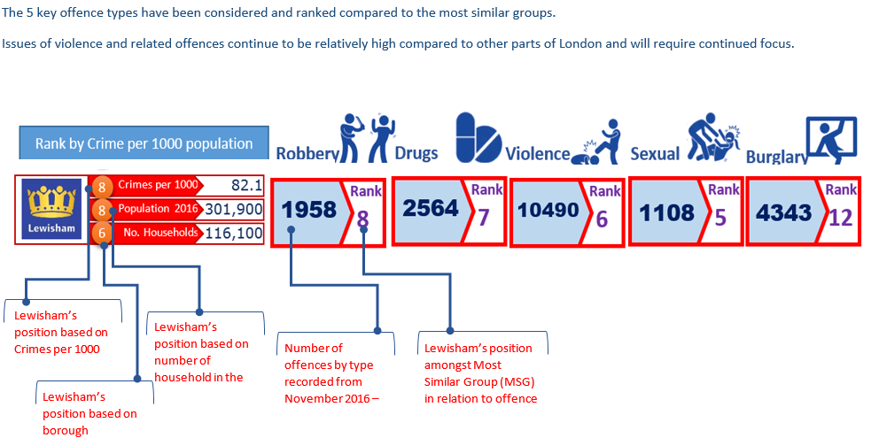

Context
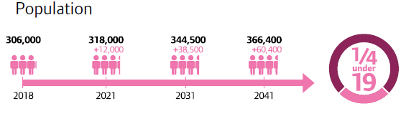
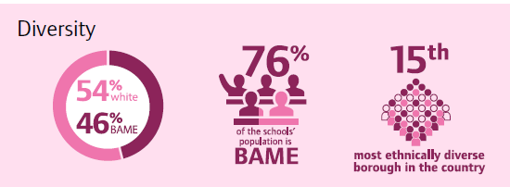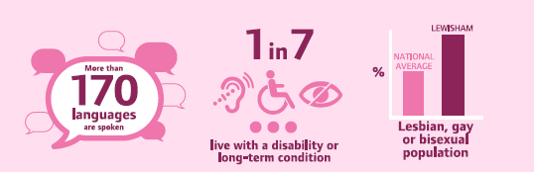

Lewisham Borough Young People Profile

- Some 25% of Lewisham’s total population is comprised of children and young people aged 0-19 years.
- Lewisham’s population is able to celebrate 160 different languages spoken by children of school age.
- Some 66% of Lewisham residents aged 0-19 are of BME heritage. This compares to some 76% of the schools population and 46% for the borough as a whole.
- Lewisham ranks 19th nationally (out of 326 local authority areas) for ‘income deprivation affecting children’, with 1 as high deprivation.
- 60% have significant speech and language concerns.
- 86% of CYP in the Youth Justice System have experienced Trauma (HMIP 2017).

In the period 2017/18 Lewisham Youth Offending Service undertook a major review based on the HMIP findings in 2016. During this year the following achievements have been accomplished:

- The recruitment of an experienced and credible independent chair who is also chair of the London YOS Assistant Director Network. The attention to good leadership and governance can improve outcomes for Children and Young People; and retains accountability for reoffending and reducing risk. The Board is now able to evidence improvement using annual self assessments of Board effectiveness. The membership and attendance of the Youth Justice Manage Board (YJMB) illustrates ownership at high Strategy level results in an increase in a widening of the partnership influence on key performance outcomes. The YJMB Performance Sub-group allows partnership work to focus on data and operational collaboration where activity is directed by the main board and in turn drives improvements.
A comprehensive Service re-modelling using the approaches successfully tested by the South London Resettlement Consortium (2014-1017). Lewisham YOS is now described as a ‘Trauma-Informed Service’ (Department of Education – Innovation Unit). 81% of young offenders have experienced trauma or adverse events (HMI Probation). The team has received extensive training for staff including handling vicarious trauma, and the secondment of a clinician to provide clinical supervision and transformational practice development. Complementing and linking the Trauma Informed response the team has been developing restorative practice which allows a specific focus on an incident to achieve learning and shift from shame therefore contributing to greater capacity to process Adverse Child Experiences (ACEs). Also complementing the strengths based model is the think family approach with a tiered offer of support and the development of Functional Family Therapy (Lewisham YOS is an accredited FFT Agency). The Board have also undertaken training on the trauma informed approach and also a session with partners to address Unconsciuous Bias.

For 2019/20 the following will be driving direction and dilvery:
- The Improvement Plan was based on a fresh, compelling, analysis of how youth justice services need to work with young people and partners and parents. This is the Trauma Informed and Restorative Practice model – now widened into the whole systems approach.
- An intensive application of data collection and analysis across the partnership to inform strategic and tactical work.
- Excellent leadership capacity at strategic and service level ensuring that the implications of the adopted Model are implemented thoroughly across the services and with partners.
- Refreshed Partnership Board functions which included close collective oversight of the Improvement Plan, Board member engagement with practice, and Board commitment to shared training on the model.
- Further embedding of the new Service design moving from a generic team to functional model of team delivery; benefits achieved so far:

INTAKE: ALL Court and First contact work (new Pre-Sentence reports, Out of Court Disposals and remands)
- Increased contact, restorative enquiry and engagement in Pre-sentence report stage
- Significant reductions in custodial sentences and rmand episodes
- Increased screening and assessment for identified needs (Child Criminal Exploitation, Speech and Language and other educational disability, and mental health).

INTERVENTION 1: Community Orders, Interventions
- More targeted, evidence –based and Trauma informed interventions 1-1 and groups
- Programs that are more consistently applied based on what works
- New Reparation and victim payback provision which are meaningful and impactfull while increasing self esteem and skills for young people

INTERVENTION 2: Custodial sentences and high risk including Intensive Surveillance and Support (ISS)
- Closer operational activity with police and Serious Youth Violence Teams to manage high risk cases.
- Enhanced ISS provision as a direct alternative to custody.
- Increased contact with young people in custody, joint work with the institutions and work on pathways to effective resettlement in the community.

Over the past year the Service has been following a partnership action plan focusing on performance information for Children and Young People, improving recording and evidencing of outcomes and ensuring the Service undertakes systematic review and implement changes accordingly. Examples of such reviews are the Joint Service Needs Assessment (JSNA, Health), Group and Individual Effective practice interventions and a comprehensive revision of all major policies (Workforce Development, Equal Opportunities, Domestic Violence, User Participation and Engagement and Joint Working: YOS &Children’s Social Care)

In addition to the attention to structural and cultural change there has been a significant drive in the Service’s ability to collect, analyse and present relevant performance data. A Live Re-offending Tracker was introduced to produce data on all those who receive a substantive outcome from Jan 17 to Dec 17. This enables us to understand key re-offending characteristics, and direct partnership reviews and activity. A good example of the application of the information obtained from the Live tracker is the data obtained on young people known to the service who are identified as having Special Education needs. These individuals are 3 times more likely to re-offend and 4 times more likely to have Domestic Violence as an adverse child experience. Another example identified is that 12 individuals are responsible for 34% of all the re-offending. In 2019 we are now able to compare data from 2018 compared to 2017 (see appendix).

The Improvement Plan for 18/19 has been achieved with all 32 actions rated GREEN and signed off by the YJMB.

Supporting the communication strategy for the partnership is the Lewisham YOS Storyboard (see supporting documentation below). This outlines the key messages and narrative for the Youth Justice Partnership to enhance understanding of the activities, methods and outcomes that we are achieving. There is also a longer version available electronically which additionally provides:
- A summary of all revised polices and other key related wider partnership strategies
- YOS work flow and process diagrams/infographics
- Logic Model charts
- A summary of the new HMIP criteria and domains. (See appendix 1)

Sustaining the Success Plan for 2019

Lewisham Youth Justice Partnership was last subject to an HMIP Inspection in September 2016. The current round of national inspections resumed in 2018 with a four year cycle and therefore it is unknown when Lewisham is likely to be inspected. The Strategic Plan was signed off by all key partners who contribute to the Youth Justice Partnership in Lewisham.

With the support of the Performance team a full self-evaluation against HMIP standards comparing September 2016 to our current delivery in December 2018 has been completed (see appendix). The evaluation offers context on the borough of Lewisham, as well as analysis of Lewisham YOS performance against four areas of Organisational Delivery (Governance and leadership; Staff; Partnership and Services and Information and Facilities Inspection Domain 1), along with exploratory against risks to service delivery, finance and key challenges for the future. Allied to the self-assessment is the repository of evidence and documentation matched to HMIP requirements.

For 2019/20 the focus will be on how the Service can continue to build upon its achievements in reducing the number of first time entrants further, maintaining strong performance in relation to reductions in re-offending and youth custody (both remand and sentenced). Key to achieving these outcomes will be the development of the Trauma-informed Restorative approach requiring.

- Another round of training on specific themes and methods to manage and process trauma to include sleep hygiene, increased understanding of the negative impact of game and social media forums.
- The strengthening of the multi-agency risk and safeguarding work via the ’Concern Hub’ (see appendix). The current structures have been under review taking into account a number of changes in our understanding and focus on a public health / whole systems approach to violence as well as rationalising multi-agency actions for exploited children.
- The evaluation and widening of the Violence Reduction Program. A 12 week group intervention which provides young people with insight into why they respond to situations with violence. It enables participants to recognise moments of hyper vigilance and manage stressful situations by encouraging positive thinking. Southbank University are undertaking an evaluation which will help shape the future implementation of the trauma –informed approach.
- A revision and enhancement of our family offer. The ‘Think Family’ strand of the YOS vision was implemented in recognition that there needed to be a focus on viewing our work with young people within the family context and environment. Most importantly, that case officers felt competent in their ability to assess familial risk and protective factors, and apply adequate intervention to support their young people. It has been assessed that more work is needed to support YOS officers to evidence that they are thinking family, however case formulation and co-production aims to remedy this.
- Further development of Speech and Language Therapy work. Having a specialist on site has enhanced the capacity of the team to engage and represent the considerable speech, language and education needs of the YOS cohort. This will include the potential to widen the role and undertake more direct assessments.
- To further embed the Restorative Justice model into the work of the Referral Order Panel. It is intended to involve the Young Person in Restorative Enquiry ahead of their attending the Panel. This engagement will then inform additional intervention with the significant parent or parents or caregiver and through this seek to address relationship harm caused by the offending behaviour. In instances where there is also a community based victim harmed in the incident, it is intended that they are to be engaged with restoratively to enhance the parties opportunity to address the event and see the matter resolved directly between them. Janine Carroll from Restorative Now will be commissioned to provide training, live coaching and buddying to staff to further embed the approach in Lewisham YOS.
- A re-design of the Out of Court Decision making process to include the introduction of a panel for joint decision making with police colleagues and further strengthen pre-court interventions.
- Contributing to the Community Champions Project by running workshops on the Trauma-informed Restorative Model. Many people in every community come into contact with young people and their families, and can be affected by these issues. These could vary from teachers and youth workers to faith leaders, sports coaches and local shop keepers and residents. We know that many of these people are worried about young people, have felt the effects of violence in their neighbourhoods, and want to play a more active role in keeping young people safe.
- Lewisham is committed to tackling and reducing the impacts of violence on our communities, supporting the Mayor’s Corporate Strategy 2019-2022; linking into strategies and plans that are in place such as the Violence against Women and Girls (VAWG) Plan 18-21, knife crime action plan 18/19, the Safer Lewisham Annual Plan 19/20 and building stronger communities programme.

B STRUCTURE AND GOVERNANCE

Lewisham YOS is positioned within the Crime Reduction and Supporting People division of Lewisham Council’s Directorate for Community Services. The division aims to reduce crime, disorder and substance misuse in Lewisham, in partnership with other agencies. Most of its functions involve the exercise of statutory responsibilities. The division is currently subdivided into the following service areas
- Crime, Enforcement and Regulation Service (which includes Neighbourhood Community Safety Service, Serious Youth Violence, CCTV, Public Health and Nuisance, Licensing and Trading Standards).
- Environmental Health
- Youth Offending Service
- Supporting People and Drug and Alcohol Services

Lewisham is taking a public health approach to reducing violence which means:
- Understanding the extent of all violence, where and how it happens and who is affected to better inform including youth violence, domestic abuse, and sexual violence.
- Understanding that violence damages physical and emotional health and can have long-lasting negative impacts. It increases individuals’ risks of a broad range of health damaging behaviours – including further violence – and reduces their life prospects in terms of education, employment and social and emotional wellbeing.
- A wide range of factors relating to individuals, their relationships, and the communities and societies in which they live can interact to increase or reduce vulnerability to violence. Issues such as Adverse Childhood Experiences (ACEs) can have significant impacts on families.
- There are a wide range of strategies that can be used to address risk factors for violence and promote protective factors across all ages. Some can be implemented universally and others are targeted specifically. Using evidence based models will shape impact.
- Working with the strengths that exist in communities to listen and collaborate on designing solutions together.
- Dialogue that challenges social norms aim to prevent violence by making it less socially acceptable.
The Aim is to:
- Reduce the impacts and actual violence across Lewisham
- Identify the causes of violence in Lewisham, and act to deliver short and longer term reductions
- Listen and work with communities to build on their strengths and deliver solutions together.
- Create a learning environment for continuous improvement.
- Impact positively on wider social, economic and health outcomes for our residents.

Building on the work already in place the following key strands of work that form the framework approach are:
- Community Dialogue
- Review of Services and Provision e.g. Early Help Review,
- Homicide and Serious Violence Cases Review and learning
- A Strategic Needs Assessment and Performance Framework
- Evidence working group
- Supporting workforce resilience and creating Trauma informed restorative aware organisations
- Youth panel
- Creation of a Violence Reduction Board

For 19-20 the Safer Lewisham Plan focussing on the detail of embedding the Public Health Approach

In taking a public health approach to tackling violence there will be a collective and whole system approach to reducing exploitation, harm and violence

Violence is not normal nor acceptable. Many of the factors that may lead to violence include exposure to violence, experiences to adverse childhood experiences (figure 1) and the environments in which we live from birth to older age. Greater understanding of these aspects will seek to promote preventative approaches, promote protective factors and build resilience for individuals and the community as a whole. Violence prevention needs to be seen as a key part of tackling inequalities.

Figure 1 - Adverse Childhood Experiences (ACEs)
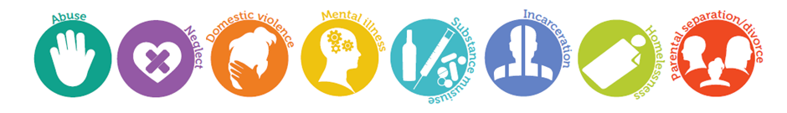
Lewisham is taking a public health approach to reducing violence which means:
- Understanding the extent of all violence, where and how it happens and who is affected to better inform including youth violence, domestic abuse, and sexual violence.
- Understanding that violence damages physical and emotional health and can have long-lasting negative impacts. It increases individuals’ risks of a broad range of health damaging behaviours – including further violence – and reduces their life prospects in terms of education, employment and social and emotional wellbeing.
- A wide range of factors relating to individuals, their relationships, and the communities and societies in which they live can interact to increase or reduce vulnerability to violence. Issues such as Adverse Childhood Experiences (ACEs) can have significant impacts on families.
- There are a wide range of strategies that can be used to address risk factors for violence and promote protective factors across all ages. Some can be implemented universally and others are targeted specifically. Using evidence based models will shape impact.
- Working with the strengths that exist in communities to listen and collaborate on designing solutions together.
- Dialogue that challenges social norms aim to prevent violence by making it less socially acceptable.
- The safer Lewisham partnership will play a significant coordinating role through the newly formed violence reduction board.

The Aim is to:
- Reduce the impacts and actual violence across Lewisham
- Identify the causes of violence in Lewisham, and act to deliver short and longer term reductions
- Listen and work with communities to build on their strengths and deliver solutions together.
- Create a learning environment for continuous improvement.
- Impact positively on wider social, economic and health outcomes for our residents.

The partnership will build on the foundations in place towards making Lewisham a trauma informed borough;

Safety -Throughout the organisation, staff and the people they serve feel physically and psychologically safe.” Guiding Principles of Trauma-Informed Care, 2014.

A trauma-informed service system and/or organisation is one in which all components of the system have been reconsidered and evaluated in the light of a basic understanding of the role that violence and trauma play in the lives of people seeking or referred to services.

ACES provide a measure of traumatic experiences in childhood are used to influnce prevention and predict future harm. According to Scottish research people with 4 or more Adverse Chid Experiences ( abuse,neglect, household dysfunction) are:
14 times more likely to have been a victim of violence over the last 12 months
15 times more likely to have committed violence against another person in the last 12 months
16 times more likely to have used class A drugs
20 times more likely to have been incarcerated at any point in their lifetime.

Lewisham will aim to adopt the following principles and apply to organisations throughout the borough:
- Safety – creating spaces where people feel culturally, emotionally and physically safe
- Transparency and Trustworthiness – full and accurate information about what’s happening and what's likely to happen next
- Choice – an approach that honours an individual’s dignity
- Voice – creating the opportunity where the individuals’ views, opinions and feeling are heard and acknowledged.
- Collaboration and mutuality – healing happens in relationship and partnerships with shared decision making.
- Empowerment – Recognition of an individual’s strengths. These strengths are built on and validated.

To achieve these outcomes the following is needed:
- Realising the prevalence of trauma through a consistently applied training program
- Recognising and supporting how stress and fear affects all individuals involved with the program, organization or system, including its own workforce.
- Resisting re-traumatisation, labelling and re-victimisation
- Responding by putting this knowledge into practice. The Trauma Recovery Model responds to readiness of intervention to underlying need.
- Restorative: Using conflict or an incident as an opportunity to repair harm and heal relationships.

The strength of our response places equal focus on victims and perpetrators to help support and bring about positive change
Studies of trauma among groups of young people found that:
- 91% of violent young offenders have experienced abuse or loss
- 40% of female and 25% of male youth in custody have suffered violence at home
- 33% of female offenders have suffered sexual abuse

Research also indicates that offenders are more likely than non-offenders to have suffered adverse effects from traumatic experiences, which appear to be linked to offending behaviour. Trauma can result in inappropriate aggression and is strongly associated with a range of problematic behaviour including violence, antisocial/criminal conduct, sex offending and substance misuse. We understand that many child and adult offenders will have been subject to a range of adverse experiences, from substance misuse problems, difficult family backgrounds including experience of childhood abuse or time spent in care, unemployment and financial problems, to homelessness and mental health problems and this knowledge underpins our trauma informed, restorative approach to tackling offending. However we also acknowledge that there are victims of the crimes perpetrated by these exploiters and our focus on supporting these victims must remain resolute.

Services for all victims will:
- Support through a recognition of trauma to assist with recovery
- Provide safety advice and planning
- Support participation in the criminal justice processes as appropriate improving compliance to the victims’ code of practice.
- Crime prevention advice for all
- Restorative approaches to help heal the harm caused.

Lewisham’s approach to breaking the victim/offender cycle will:
- Focus on both the individuals and their families, understanding the dynamics of these relationships and interactions.
- Aim to stop re-victimisation within interpersonal relationships.
- Explore appropriate perpetrator desistance programmes.
- Create approaches to tackle specific victim/perpetrator relationships
- Focus on how perpetrators are supported to change and understand the impact of their harmful behaviour.
- The multi-agency Concern Hub which works with children under 25; those who are missing or who are victims of child sexual exploitation, child exploitation, harmful sexual behaviour, county lines, serious youth violence and gangs.
- Challenge social norms to making interpersonal violence of all kinds less socially acceptable.
- Coordinate this work through the Violence Reduction Board, the Concern Hub and the Violence Against Women and Girls Steering Group.

The Lewisham Youth Justice Management Board is responsible for the work of the Youth Offending Service and the wider crime prevention partnership. Following the conclusion and proposals for change outlined in the HMIP report the board has undergone a complete review, including the introduction of an independent chair. The Chair has introduced the following new components:
- A self-assessment framework to evaluate effectiveness for participant members.
- A revision of the terms of reference for both the Quarterly Main board and supporting Performance Sub-board.
- Activities outside of the meeting to strengthen Strategic and Operational working to improve ownership of Youth Justice Priorities across the partnership.
- Lead Board member for each section of the improvement plan and clarity of responsibility for implementation.
- The introduction of a Principal Policy Officer to act as Clerk for the meeting, co-ordinate actions and support the YOS Strategic Manager to update service policies.
- The Board is required to monitor the performance of the prevention of youth crime agenda and ensure the delivery of statutory principal aims at local level. This includes reducing the likelihood of reoffending by young people and the risk of harm that they can cause to other people and themselves.

The Lewisham YOS Performance Sub-board is responsible for monitoring objectives linked to performance indicators, measures and outcomes, within the national framework established by the Youth Justice Board, as well as other locally agreed priorities. Key statutory requirements include data collation, analysis, completion of national standards audits and other reviews.

The YOS has a place at the following Boards and Forums:
- Safeguarding Children’s Board (and relevant subgroups including Early Help Strategy Board).
- Multi-Agency Public Protection Strategic Management Board
- Risk Management Group including Child Sexual Exploitation and Missing Persons
- Integrated Offender Management.
- Safer Lewisham Partnership Board and relevant sub groups
- Lewisham Inclusion Board ( education attendance and achievement)
- Lewisham Health and Wellbeing Board

The YJMB has prioritised the collection, analysis and application of a dataset to evidence progress in the HMIP Improvement Plan (see below with current RAG ratings):

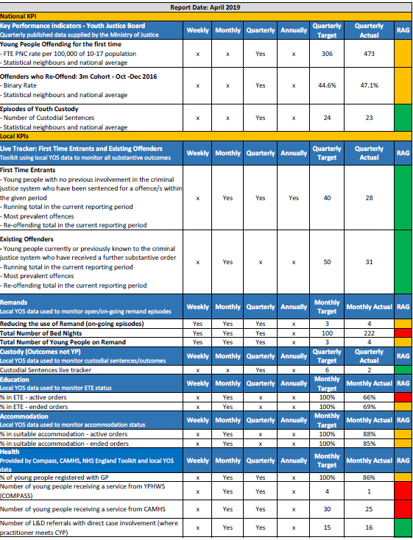

Data and Performance Outcomes:

In 2018/19 the YOS has introduced a monthly data oversight meeting attended by all managers and a NEET review meeting to review progress on reducing the numbers who are not in education training or employment. The creation of management oversight monitoring reports by the YOS Information officer has contributed significantly to being able to quality assure and drive up recording performance. The ‘crystal reports’ are used by Line Managers in monthly supervision for data cleaning and case decision making.

The last quarters KPI (Oct- Dec18) is showing the following:

- FTEs down 24.1% ( this is a bigger reduction than the London average but not as much as our YOT family – FTEs are reducing by 22.7 % average across London-Lewisham 151 per 100,000 less).
- Re-offending down 16.5% (from 56.3 (Jan –March 16 compared to cohort tracked since Jan-March 17 – 39.7%). This is one of the biggest reductions in London and we are now one of 10 YOTs in London who are under 40% and below the National average.
- Custody down 45% (23 compared to 44 previous year). This has now been consistent for last three quarters showing we can maintain improved performance.
The YOS has completed the year on year Live Tracker comparison 2018 compared to 2017. (See PowerPoint appendix 4) The live tracker has proved statistically accurate to date. Headlines are:
- Further reductions in FTEs – 29% average
- Further reductions in re-offending will prove challenging as cohort size reduces
- Significant reduction in young women and girls in the Youth Justice System (52%)
- Small increase in looked after children entering the Youth Justice System (9%)
- Positive reduction in BAME entering the Youth Justice System (33% compared to 29% white).

In light of the above Lewisham YOS has been deescalated from their previous status of ‘priority’ YOT under the previous assessment approach. As such the YJB will not continue to engage as closely as it has over the last period of time, and for example will step back from attending our boards.

In November 2017, 29 agencies attended a conference chaired by the YJMB chair to work with partners specifically on tactics to reduce further the First Time Entrants to the Youth Justice System. Highlighted was the 97 Children and Young People Lewisham would have to reduce in the next year to reach the national average. The focus was on:
- What do we know about the Young People (characteristics) entering the system?
- What could we do better?
- What more can the partnership do to prevent criminalisation and offending?

The subsequent FTE partnership plan has resulted in:

- A new framework for working with Youth First (Lewisham’s Youth Service) including the provision of the Universal Schools Safety Program (USSP) for year 7 pupils.
- The inclusion of reducing First Time Entrants as a key indicator for the Children and Young People’s Plan.
- A strengthening of the relationship with Compass (the Children and Young People’s health service), which includes a health and wellbeing program for triage cases.
- A widening of the brief for the NHS England-funded Liaison and Diversion project, with all young people who are arrested having contact with YOS staff at the police station or court as the new aim.
- Training across the partnership on Unconscious Bias, which recognises that decision making at early stages of development and other important transitions contributes to over-representation and disproportionality.
- Continued extension of Restorative Justice in schools and other important environments.
- The YOS/CSC LAC interface sub-group to address factors that pre-dispose Looked after Children and Young People to criminalisation and over-representation.
- More community-based parenting support
- The revision of the schools Knife Crime Protocol
- An increased attention to Speech, Language and Communication Needs (SLCN) to build increased awareness and capacity to support.
- Further development of the community trauma model targeting specific locations to create safer spaces.
- A new narrative for understanding and communication on violence and the public health approach to reducing incidents of violent behaviour.
- Strengthening links to Early Help and preventative strategies
- Enhanced understanding of the role social media plays in influencing young people
- Making sure we routinely obtain the views of Children and Young People for co-production and review e.g. ‘Ask, Listen, Act’ (ALA).

First Time Entrants

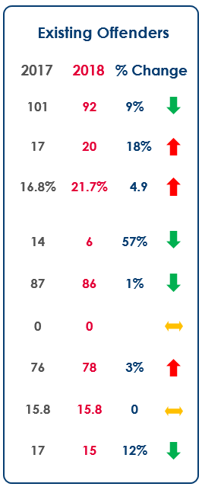

Reducing Re-offending

The 2017 and 2018 full year cohorts are being tracked for rate of re-offending on a monthly basis.

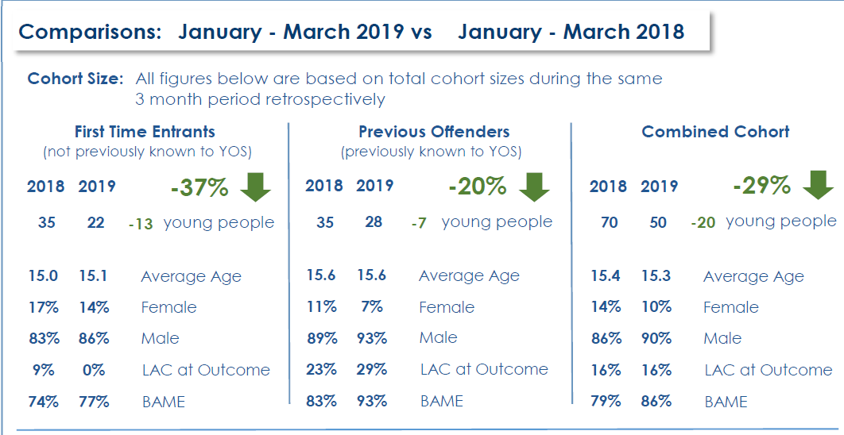

Reducing Custody:
The partnership undertook a review of the custody cohort in early 2017 due to concern about the numbers and comparatively high rates compared to statistical neighbours. Identified were a number of factors including levels of serious violence, group offending and lack of programs and capacity in the YOS, especially in relation to ISS. As a result the following actions were undertaken:
- A review of the PSR quality assurance process, to remove negative bias and become trauma-informed.
- Increasing capacity of Intake team to undertake comprehensive assessments and screenings for vulnerability and safeguarding needs (e.g. CSE, RJ, SAL, Diversity)
- Formal discussions with Bromley Youth Court to introduce the Lewisham YOS Trauma-informed and restorative model.
- A comprehensive review of the Victim Liaison Service provided by Lewisham YOS
- Intervention Team 2 (high risk cases) increased its resources to deliver ISS
- Launch of the borough-wide county lines toolkit and partnership activity which focused on protective measures to safeguard children.
- A review of all programs and the roll out of new 1-1 and group interventions including the piloting of a trauma- informed weapons and violence reduction group.
- A partnership approach to Resettlement and an enhanced offer to children leaving custody.

The result has been a significant reduction in custodial sentences (as per the 50% reduction seen on the Live tracker chart below). For example, there were 25 custodial sentences in March-June 17, and only 2 in Jan- March 19).

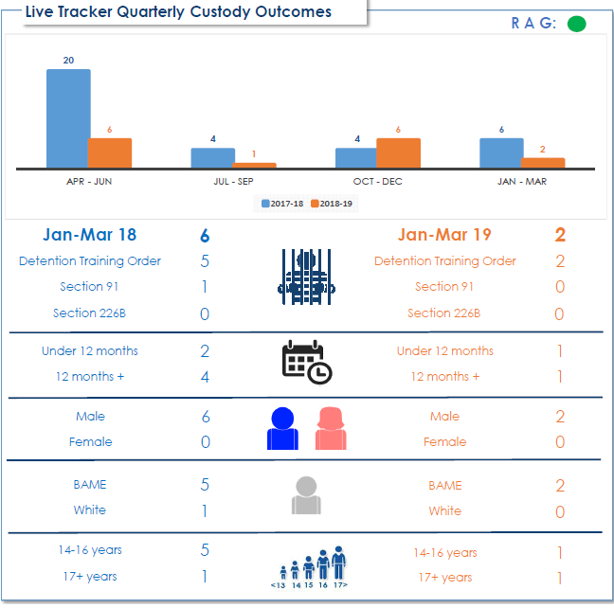

C RESOURCES AND VALUE FOR MONEY

The number of young people that Lewisham YOS works with has reduced over the past five years, but the level of complexity, risk and vulnerability has continued to increase. As of June 2019 the YOS is working with the following cohort of young people, which is broadly representative of the past twelve months:
- 203 young people were worked with by the YOS on Out of Court disposals or Court Orders.
- 27% are Out of Court Disposals ( Triage and Youth Conditional Cautions)
- 80% of the cohort are male
- 70% of cases have committed offences of violence or drugs ( possession and supply)
- Most young people are sixteen and seventeen, with an increasing number of eighteen year olds subject to Youth Orders.
- The ethnic breakdown of the young people is broadly reflective of Lewisham’s youth population, except when considering the young people in custody, whereby young men from Black and Mixed Heritage backgrounds are over represented.
- 20% of young people are LAC: 12% are Lewisham LAC and the remainder are placed in borough from other areas.
- Between 50 – 60 young people are NEET at any one time

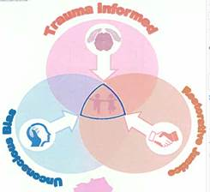

The Delivery Model-Trauma-Informed Practice: The Service is progressing the approach to embed and integrate across every element of the work. The roll out of the Case Formulation (Co-production) model has commenced and is currently being tested on 10 high risk cases.

Case Formulation: This is a multi-agency case reflection meeting which is conducted following sentence. It is the critical analysis and joint action planning, (the bridge between Assessment and Planning) which ensures agency roles and responsibilities are clear and that there is an agreed ‘product’ to share with the young person and family.
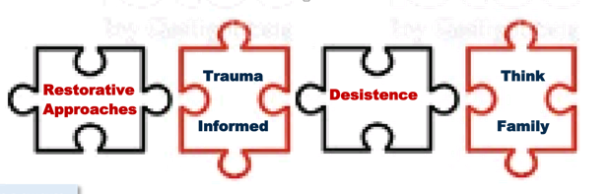
The staff team continue to receive one-to –one clinical supervision. The management team have participated in an Away Day with the clinical psychologist to reflect on the progress in moving towards a trauma-informed service. It was recognised that there is still a long way to go in terms of embedding the approach consistently so that practitioners are able to apply evidence, method and outcomes. Lewisham YOS’ Trauma-Informed service offers:
- Consistent and meaningful contact and trusting relationships
- ‘Voice’ of young person heard
- Removal of bias labelling and re-victimisation
- Moving to secure, organised attachments
- Reducing fear through reduced stress/anxiety
- Partners co-delivery of the approach
- Monthly 1-1 clinical supervision for staff
- Co-production and case formulation
- Intensive and consistent practitioners
- Interventions that process trauma to manage behaviour

Restorative Justice: The service continues to lead the roll out of RJ across the partnership. Restorative Now are currently engaged in a whole school approach at Abbey Manor College Pupil Referral Unit providing peer training, twilight sessions, and coaching. Staff from the school have also attended a crossagency three-day training event, together with CSE police officers, representatives from Lewisham Childrens’ homes providers (reducing criminalisation) and new YOS staff. Followup coaching and buddying will be provided as part of the integration of skills and also the potential for a network practice forum between participating agencies.

Unconscious bias: All Team members have completed a series of one-day, joint training sessions with the Crime Enforcement and Regulation Team on increasing awareness and understanding bias in its many forms. This was followed up with the provision of further training days for the wider partnership during May/June 18. A whole YOS team follow-up exercise has highlighted that there are many positive approaches that are used across the work streams to address negative bias (Court reports, interactions with young people, Restorative and TI approaches) but also much more that can be achieved using the ‘Identifying the potential bias at each stage’ framework seen below:

 Reflect, Reframe, Redirect
- Challenge without shaming
- Check response and reflect with colleagues
- Examine cultural assumptions
- Use the GRACES as a framework (Gender, Race, Religion, Age, Ability, Appearance, Class, Caste, Colour Culture, Sexuality, Spirituality, and Sexual Orientation.

User Engagement: Ensuring the views of Children and the Community are heard:

The Lewisham Youth Offending Service is embedding a culture which recognises learning across all levels of the service and values the importance of the voice of the child. This is more than a response to the legal requirement under the United Nations Convention on the Rights of the Child, and is about ensuring the promotion and protection of human rights, specifically through Article 12 which states that ‘children have the right to participate in decision-making processes that may be relevant in their lives and to influence decisions taken in their regard'. It is a belief that children and young people (CYP) aged 17 and under should have opportunities to express their opinion in matters that affect their lives. To do this we need to create opportunities for CYP to play meaningful roles at an operational level, as well as in decision-making structures and thereby making young people part of the governance arrangements.

We believe that every person working with children, young people and families, from senior managers to frontline staff have a role to play in participation. The everyday practice for staff should be to support CYP to have a voice. Listening to CYP is not an ‘add-on’ to programmes or work activity. Participation is not achieved in one-off surveys or meetings; it is part of an ongoing process and practitioner ‘mind-set’ that establishes and utilises good lines of communication between those who provide services and those who use them.

Our vision is for the YOS to be a service where CYP feel that their views and experiences are encouraged, valued, respected and most importantly acted upon to shape services that meet their needs. Examples to date have been:
- Focus groups to consult on Referral panel
- Advice and input into Trauma-Informed Violence Reduction Program
- Young person participation in Youth Justice Management Board engagement session
- Participation in our community converations and safer spaces survey
- The appointment of a Young Person to be a YOS rep to advise the team and the YOS board on how in the future we make better decisions as we include the voice of young people in Lewisham.
- Identifying Youth leads who will convene and facilitate the Lewisham Youth Panel to act as an advisory group to the YJMB, Safer Lewisham Partnership and Violence Reduction Board.

Listen Hear Act
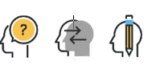

A Rationale for Change: Lewisham YOS has experienced a significant reduction in budget since the last restructure in 2013. In 2017 the business case was made to fund an increased capacity in the YOS to implement the service re-design and the enhanced requirements arising from the HMIP Improvement Plan, which resulted in four growth posts (I x Operational Manager and 3 x Youth Offending Officers). We have also benefitted from the commissioning of an independent Board Chair and Consultancy post. Although the council is unable to approve a permanent £250k growth the service is able to continue with these additional posts for next year assuming income does not fall. Lewisham YOS is always running with an over spend on the remand budget. This was devolved to local authorities in 2013 due to high numbers of young people being placed into custody prior to sentencing, forserious or persistent offending. As a result of this, there will be a shortfall of £301k based on predictions for remand overspend.

Partner contributions to the youth offending partnership pooled budget 2019/20

Lewisham YOS: Financial Commitments 2019/20

Agency | Staffing Costs | Payments in kind | Other delegated funds | Total
Police | 0 | 80,000 | 0 | 80,000
Police and Crime Commissioner | 0 | 0 | 0 | 0
Probation | 75,000 | 0 | 10,000 | 85,000
Health | 106,456 | 0 | 0 | 106,456
Local Authority | 927,017 |  | 99,630 | 1,026,647
Wales Assembly Government | 0 | 0 | 0 | 0
YJB | 495,846 | 0 | 0 | 495,846
Other |  |  |  | 0
Total | 1,609,033 | 80,000 | 109,630 | 1,798,663

Staffing accounts for 90% of annual expenditure across the service each year with only a small number of contracts and external services provided. For 2018-19 this will include:
- The Appropriate Adult Service
- Making Tracks Half term and Summer projects ( Arrs awards)
- Young Lewisham Project (reparation)
- The Conservation Volunteers (reparation)

Lewisham Youth Offending Service works within the financial regulations of Lewisham Council. These ensure that all expenditure is commissioned in a fair and transparent manner and expenses are made in line with the relevant funding grants. All expenditure is overseen by the Youth Justice Management Board; daily management is delegated to the Strategic YOS Manager and monthly finance meetings take place with a nominated Council finance officer.

Effectiveness informing decision-making: Lewisham YOS has trained staff in the use of Project Oracle and the Theory of Change. Each team has a Logic Model and set of RAG rated outcomes to drive performance improvement (see appendix 3). The Operational Managers use these to engage their staff in ownership and achievement of positive outcomes.

TRAUMA - MODEL ∆
Case formulation → Relational Plan → T-I Interventions → sustaining the change

INTAKE TEAM  Operational Manager  Senior Practitioner | INTERVENTION TEAM 1  Operational Manager  Senior Practitioner | INTERVENTION TEAM 2  Operational Manager  Senior Practitioner
Out of court disposals (YSOs)  Short Referral Orders (YSOs and YOS Officer)  New Pre-Sentence Reports(YOS Officers)  Initial screenings/assessments  Remand ( Qualified Social workers)  Court Duty (YOS Officers, Qualified Social Workers)  Bail supervision  Liaison & Diversion  Duty | Youth Rehabilitation Orders(YROs)  Groups  Junior Attendance Centre  Referral Orders  Reparation  Unpaid work  Detention and Training Orders on existing cases | YROs with ISS (YOS Officers – 1 x YSO)  YROs prolific (YOS officers)  DTOs (YOS Officers)  Sec91s and 226 3 year plus sentences  Serious Youth Violence/Missing Exploited Trafficked)

INTAKE TEAM:
- Responsible for all new Pre-sentence reports, initial ASSET+ screenings and assessments and commencement of case formulations.
- Manage out of Court disposals including Liaison and Diversion and short Referral Orders via Youth Support Officers.
- Responsible for the staffing of Court and managing bail support and remand.
- Responsible for duty

INTERVENTION TEAM 1:
- Case manage Youth Rehabilitation Orders including post court case formulation, planning and delivery of interventions
- Case manage Referral Orders not managed by Intake
- Responsible for Core interventions, individual and group.

INTERVENTION TEAM 2:
- Hold all other custody cases including Sec 91s.
- Manage cases assessed as high risk of harm to others including Intensive Supervision and Surveillance.
- Work closely with the Serious Youth Violence Team


D PARTNERSHIP ARRANGEMENTS

Lewisham Council has an overarching vision for the borough which informs everything it does: ‘Together we will make Lewisham the best place in London to live, work and learn’. The vision is shared with key partners and the Sustainable Community Strategy (SCS) outlines how all partners will work towards the vision by contributing to six key priorities. The Council, in turn, has developed ten corporate priorities to articulate its contribution to the SCS and these priorities form the heart of strategic planning.

The Safer Lewisham Partnership ‘Safe’ Plan 2018/19 identifies 3 overarching priorities for the partnership:

- How do we become a less violent society?

Exposure to and actual violence impact significantly on communities and individuals. Violence covers serious youth violence, peer on peer abuseand gender-based violence including domestic abuse. These crimes are high harm and contribute significantly to all crime borough-wide.

- How do we shape a better place and space?

Research has gradually evolved to recognise the role that contextual, as well as developmental and familial, factors play in the process of adolescent development. The social spaces where young people spend their time is a key area of consideration when developing approaches.

As young people explore and assert their independence from family contexts during adolescence, the relationships they form outside of their homes, and the nature of the spaces in which these form, influence their exposure to safety, risk and abuse.

- How do we ensure negative bias is recognised and acted upon?

A number of reports have evidenced the disproportionate impact on aspects of our community through the Criminal Justice system. It is clear that the language used to describe issues, individuals and agencies needs to be objective and unbiased to ensure that fairness and equality is at the heart of approaches by all.

Social cohesion and integration are at the heart of tackling discrimination, with open and regular community dialogue being crucial.

Key Partnership Arrangements

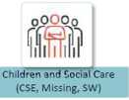

Joint Youth Offending Service/Children Social Care Policy 2018: The policy has undergone a complete refresh and offers clarity about respective roles and checklists for responsibilities in relation to Community Orders and Custodial sentences. Best practice for preparing young people for release from custody and preventing homelessness and accommodation standards is now aligned between the teams.

Exchange of information about serious violence and county lines concerns to formulate collaborative approaches to young people trafficked or exploited through drug dealing: This theme has also been subject to joint service approaches through the Lewisham Safeguarding Children’s Board. A joint audit of cases where CYP were Missing, Exploited or Trafficked was undertaken to identify any gaps or areas for improvement.

A focus on ensuring child placements manage behaviour appropriately and restoratively to prevent criminalisation or escalation of offending: Varying practice has been seen from In-borough children’s homes in relation to using the police appropriately and resolving low level bad behaviour without recourse to arrest as well as knowing when to use police intervention.

For 2019/20 the borough will benefit from the ‘Concern Hub’ - a multi-agency response to reducing serious youth violence and exploitation for children.

Concern Hub:

The focus of the change is:
- To provide a preventative offer of support for the client and family with earlier identification of risk
- To provide a multi-agency forum to jointly risk assess/ safety plan and agreed joint actions and lead agency
- To use a contextual safeguarding approach to make short/ medium and longer term change
- To join up resources across a cohort to avoid duplication

The focus will:
- remain on the under 25 year olds
- use the violence Reduction hub model (appendix A) as a basis
- include the Missing, Exploited and Trafficked cases
- include the current Serious Youth Violence cohort of Red, Amber
- include Habitual Knife Crime subjects
- include the green cases from the Met police Gangs Matrix

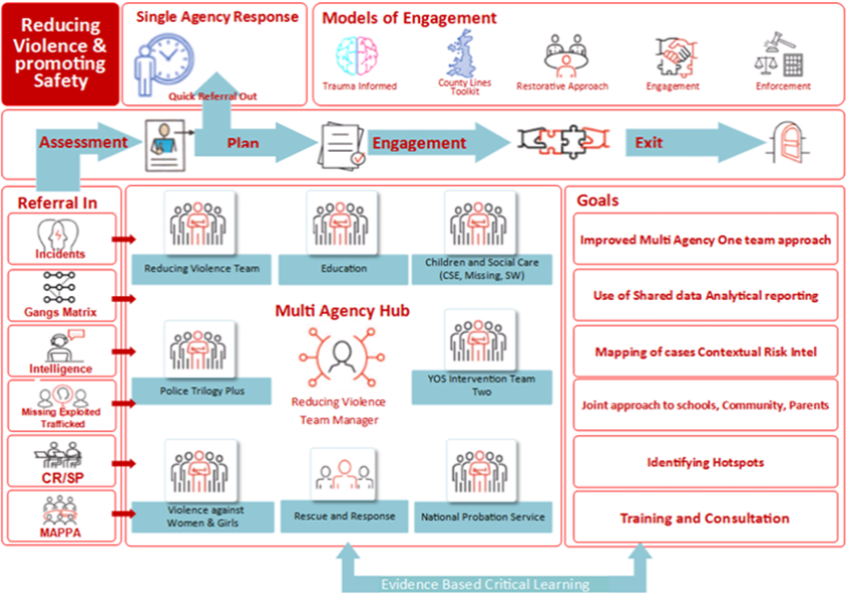

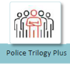
MET Police: Lewisham Police have remodelled their Integrated Offender Management (IOM) model, embedding the YOS police officers and their work alongside the wider IOM team and Trilogy gang offender team. There are two YOS police officers who deliver their work in line with the Pan London model and have contributed significantly to the improvements in Out of Court disposal practice. The joint partnership activity relating to county lines tracking, the Missing, Exploited and Trafficked Policy and the new Rescue and Response Mayors Office funded project will ensure Lewisham remains at the forefront of best practice as recognised by the YJB below:

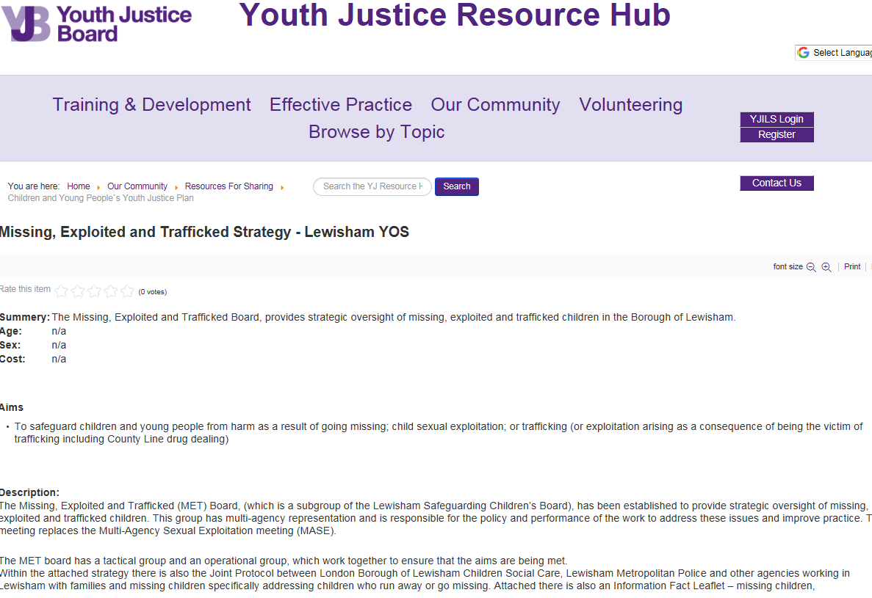

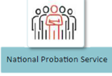

Probation: Lewisham YOS has maintained strong relations across both aspects of the Probation Service – the National Probation Service (NPS) and the Community Rehabilitation Company (CRC). An increase in resource from 1 to 1.5 dedicated probation officers will continue in Lewisham under the NPS. The NPS maintain a focus on holding cases and transferring cases to adult services. The probation officers will continue to be part of the YOS team and will contribute to all areas of service delivery and the new Reducing Violence hub. Lewisham and Southwark YOS are working in partnership with NPS and are piloting a new transitions program to further improve Youth to adult transitions. The modular program starting at under 18 and continuing post 18 bridges the gap caused by transitioning and aims to support and enable young adult offenders to successfully transfer from youth justice to the adult criminal justice system and from adolescence to adulthood. Essentially, it seeks to equip young adults with the knowledge and skills required to navigate the many challenges faced by members of this cohort, empowering them to make the necessary long-term behavioural changes that will help them reach their full potential and live purposeful, productive and crime-free lives (see appendix 8).



Health: Lewisham YOS has a well-resourced and comprehensive CAMHS Service which is co-located at the YOS.
The Young People’s Health and Well Being Service will deliver a range of health support including a substance misuse service delivered by Compass, providing holistic support to YOS clients through a local, young person’s centre, The Hub.
Following a JSNA in 2017 which was commissioned by the YJMB, new recommendations were included in planning, with the following notable outcomes:
- A range of health screenings across the board including Strengths and Difficulties Questionnaire (SDQs) as standard to identify needs and vulnerabilities.
- The bringing of the Liaison and Diversion post directly into the YOS from CAHMS.
- Service now based around the trauma-informed model and health and wellbeing at work including mindfulness for staff.

For 2019/20 the service will undertake a major review of the health and well-being provision centred around the Public Health approach:
- Review of CAHMS forensic service
- Review of Functional Family Therapy and Family work
- Further development of Speech and Lanaguage Therapy (SALT)
- A comprehensive in house training program to cover: Trauma refresher and new workshops (sleep and anxiety) and Social media impact and assessment tools).
- Continuation of the successful Liaision and diversion service at the police station
- Strengthening of the partnership with COMPASS young people’s health and wellbeing service

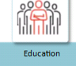

Education: A robust partnership exists across the YOS, the Local Authority’s Education Department and local schools, colleges and the PRU. The YOS Youth Engagement Officer is a joint appointment, funded by the YOS and the Education Department and this will continue for 2019/20.
In addition the YOS has commissioned a Speech and Language Therapist to build on the work that has already commenced on improved screening, staff awareness and use of specialist resources (Durham model). The partnership work recognises the importance of the SEND strategy and clear pathways and arrangements of assessment and planning for children with educational needs.

E Risks to future delivery against the youth justice outcome measures

The Youth Justice Management Board have been mapping risks to future delivery and RAG rating them below:

 |  |  |  | Pre Mitigation ranking |  |  |  | Post Mitigation ranking
No | Date raised | Description & Consequences | Owner | Likelihood | Impact | Score | Mitigation (s) | Likelihood | Impact | Score | Last reviewed | Status
1 | 09/05/17 | No terms of reference for YJMB Board | GR | Low | High | 3 | Complete terms of reference | Low | Low | 1 | 12/06/17 | Completed on 9 /6/17
2 | 09/06/17 | Partnership analytic capacity: speed of improvement is at risk without adequate analysis re data on system.  Ensuring sufficient capacity | GR | Medium | High | 2 | Identify and deploy shared resource available | Medium | Medium | 3 | 20/04/18 | Support from Partnership Analyst has helped growth of in-house team skills to stable position. Need to maintain this in Business continuity planning
3 | 09/06/17 | Ensuring skilled workforce is recruited and sustained | KC | Medium | Medium | 4 | HR strategy | Medium | Medium | 1 | 26/02/18 | All posts filled.
4 | 09/06/17 | Unmet physical health and mental health needs of young people | CM | Medium | Medium | 4 | Implement JSNA | Low | Medium | 2 | 20/07/17 | Unmet need likely to reduce due to new Compass service and active implementation of JSNA findings
5 | 09/06/17 | Young people with high levels of risk and vulnerability (nature and complexity).This now also sits between MET, emerging contextual safeguarding service and YOS | KC | High | High | 6 | Case management system | Medium | Medium | 4 | 22/03/19 | Lewisham is moving away from MET and towards the Concern Hub This process carefully manages data, with full consideration given to the recent learning gained from the Gangs Matrix review.
6 | 09/06/17 | Recruitment of core YOS staff to new service model | KC | Low | High | 3 | Recruitment strategy | Low | Low | 1 | 22/09/17 | Completed
7 | 09/06/17 | Capacity for YOS staff to be able to deliver new model | KC | Low | High | 3 | Training and support strategy | Low | High | 3 | 26/02/18 | On-going review
8 | 09/06/17 | Trauma-informed approach and how this is embedded beyond YOS internal and within Police re consistency and use of TI language etc. | GSM  KC  AF | Medium | Medium | 4 | Promotion of Trauma Informed work at Lewisham strategic boards | Medium | Medium | 3 | 26/02/18 | Embedding of T.I. model still ongoing
9 | 09/06/17 | Serious Youth Violence remains a major concern for the YOS. The level of risk being managed, coupled with the seriousness of the cases intensifies the risks. 70% of all cases on the Live Tracker involved violence, drug-dealing and weapons. | AF  GC | High | High | 9 | Responding to Mayor’s knife crime strategy | High | High | 6 | 22/03/19 | The framework around Lewisham’s Public Health approach to violence is being developed to include a new governance structure and Violence Reduction Board, which will report to SLP.
10 | 09/06/17 | Vicarious trauma and resilience of staff | KC | Medium | Medium | 4 | Internal training and Clinical supervision | Medium | Medium | 4 | 26/02/18 | No change
11 | 09/06/17 | Key partner engagement with the YJM Board at right seniority | GR | Medium | Medium | 3 | Chair engagement with partners to redress gaps | High | Medium | 3 | 05/12/18 | Discussion with representatives from Court and Education taking place. Inductions for new members have been taking place.
12 | 09/06/17 | Ensuring that key partners at board and meeting level work towards greater consistency re language and messages. | AB  SW | Medium | Medium | 4 | Promotion of Trauma informed language at strategic level | High | Low | 3 | 05/12/18 | SLP discussions and Board agenda track this
13 | 13/06/17 | Three KPIs do not improve in the 12 Month period | KC | Medium | High | 2 | Improved Board scrutiny at PSG and Board and coherent actions to address | Medium | High | 2 | 05/12/18 | Significant improvement in KPI data being reported to Dec 18 Board
14 | 13/06/17 | Readiness for any Inspections | KC  GR | Medium | Medium | 4 | YOS Staff activity targeted towards inspection readiness in whole service and individual team meetings, the continued application of training and individual performance management. | Medium | Medium | 4 | 05/12/18 | Board Dec 18 will review self -assessment of Domain 1 done in summer 18 Greenwich review
15 | 13/06/17 | Partnership structural changes e.g. Police - the new policing regime coming through points to a continued reduction of police staff numbers. | GR | High | Medium | 6 | Ensure partnership discussions at board re potential changes and implications. | High | Medium | 4 | 22/03/19 | The YOS reports that Borough Command changes have had a positive impact on the service to date.
16 | 13/06/17 | Sustainable Funding – both local Partnership and central funding pressures | GSM | Medium | High | 6 | MOPAC funding, YJB funding 18/19 and Budget Planning 19/20 to be considered | Medium | High | 6 | 22/03/19 | Currently awaiting YJB practice grant announcements due in May 2019 (TBC).
17 | 20/04/18 | MET Knife Crime & Drug Strategy: Expectations that FTE and Custody figures for young people will rise in 18/19, due to Stop and Search being used more widely. Is a separate action plan required around this action? | GR  GSMKC | High | High | 9 | Review of OOCD informed by HMIP guidance. | high | high | 9 | 22/03/19 | Continue to monitor.
Risk scoring matrix:
Impact
High
3 | 6 | 9
2 | 4 | 6
1 | 2 | 3
Medium
Low
Low Medium High Likelihood

Key challenges for Lewisham in 2019-21 (Report by the Independent Chair)

Now that the Board has overseen the completion of the two-year improvement plan (2017-19) and indicators of core performance and culture are moving in the right direction I see these as some of the key priorities for the next two years.

1) Continuing to learn, across the partnership, how to implement a trauma informed restorative model of working. The evidence of impact is strong but we are only part of the way along that journey with much more practice learning to develop. This is fundamental to our contribution to the Safer Lewisham Plan and the Violence Reduction strategy.

2) Sustaining the focus on young people in the youth justice system, as some of the most vulnerable young people in Lewisham, in the face of very significant and continuing structural and priority changes in the partner services, suchg as:-
- Probation as it transfers to a simpler single agency model
- Local and regional safeguarding arrangements
- Sub regional structures for police
- City hall and national priorities related to violence reduction
- Changes in the role and remit of the national Youth justice Board
- The changes in responsibility for youth custody and the new secure school model likely to open at Medway

3) Keeping a close focus on accountability and inspection responsibilities over youth offending services
- The HMIProbation Inspection Framework
- The new National Standards and impact for Boards and services
- Ensuring that we are an effective Board as judged by support challenge and impact measures

But at the core is keeping a close link to the way young people families and communities live their lives in Lewisham – the opportunities, the risks, the barriers (such as SEND or trauma) which they face, the emerging trends, challenging unfairness based on gender or ethnicity within the system. At its heart is the principle that the more we know the young people the better we can shape the service to meet their needs and help them live a positive life in the future.

Appendixes:
- Storyboard
- HIMP Improvement Plan 2018/19
- Safe Plan priorities
- Annual review of Live tracker 17/18
- First Time Entrants action Plan

