London Borough of Lewisham Nitrogen Dioxide Diffusion Tube Survey 2017


Prepared by: 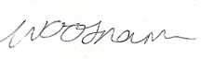 Checked by: 
Olwen Woosnam Julian Mann
Graduate Air Quality Scientist Air Quality Scientist

Approved by: 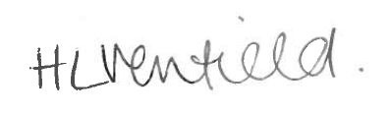
Helen Venfield
Senior Air Quality Consultant

London Borough of Lewisham Nitrogen Dioxide Diffusion Tube Survey 201

Rev No | Comments | Prepared by | Checked  by | Approved  by | Date
1 | Draft Report | OW | JM | HV | April 2018

9th & 10th Floors, Sunley House, 4 Bedford Park, CR0 2AP
Telephone: 020 8639 3500 Website: http://www.aecom.com

Job No 60194269 Reference Date Created April 2018

This document has been prepared by AECOM Limited for the sole use of our client (London Borough of Lewisham) and in accordance with generally accepted consultancy principles, the budget for fees and the terms of reference agreed between AECOM Limited and the Client. Any information provided by third parties and referred to herein has not been checked or verified by AECOM Limited, unless otherwise expressly stated in the document. No third party may rely upon this document without the prior and express written agreement of AECOM Limited.

1 Introduction 1
Table of Contents
2 Legislative Background 2
3 Monitoring Methodology 3
3.1 Description of Network 3
3.2 Procedures and Site Changes 3
3.3 Tube Preparation, Analysis and Laboratory QA/QC 3
4 Results and Discussion 6
4.2 Bias Adjustment 6
4.3 Annual Mean NO₂ Concentrations 8
5 Conclusions 12

Appendix A: Diffusion Tube Monitoring Locations in Lewisham 14
Appendix B: Monitored NO₂ Concentrations 16
Appendix C: Diffusion Tube Bias Adjustment 19

Table 1 UK and EU Air Quality Objectives for NO₂ and NO_{X} 2
Table 2 Site Type Designation Criteria 5
Table 3 Comparison of Diffusion Tube Measurement and Continuous Monitors at Co-located Site 6
Table 4 Annual Mean NO₂ Concentration (Bias Adjusted), 2017 8
Table 5 Monthly Mean NO₂ Concentrations in Lewisham, 2017 (µg/m³; Unadjusted) 9
Table 6 Unadjusted Winter and Summer Period Mean Concentrations in Lewisham, 2017 9
Table 7 Annual Mean NO₂ Concentration (bias-adjusted) by Site Type, 2012 – 2017 11
Table 8 Lewisham Diffusion Tube Network 2017 – Raw and Bias Adjusted Results 16
Table 9 Summary of Local and National Bias Adjustment Factors for Lewisham NO₂ Diffusion Tube Surveys, 2009 to 2017 19

Figure 1: Comparisons of Chemiluminescent Analyser and Diffusion Tube Measurements at AQMS New Cross for 2017 6
Figure 2: Seasonal Trend of NO₂ Concentrations in Lewisham, 2017 10
Figure 3: LB of Lewisham Diffusion Tube Network (South) in 2017 14
Figure 4: Local Bias Adjustment Factor Calculation, Lewisham – New Cross (LW2) 20
Figure 5: National Bias Adjustment Factor Calculation 21

AECOM was commissioned by the London Borough of Lewisham to install and maintain a network of NO₂ diffusion tubes to assess the spatial variation of nitrogen dioxide (NO₂) concentration within the Borough. The diffusion tube network in 2017 comprised of 37 NO₂ diffusion tubes at 35 locations, one of which is a triplicate tube location with all others comprising a single tube. Since the start of 2018, 16 new locations have been added, and Stanstead Road (L25) has been decommissioned. The diffusion tubes were exposed for periods of between 4 and 5 weeks in accordance with the UK NO₂ Survey Timetable. The results of the survey provide Lewisham Borough Council with valuable monitoring data for use in their Local Air Quality Review and Assessment (LAQM) process.
- Introduction
This report outlines the results of the survey for January 2017 to December 2017, inclusive. The spatial variation in NO₂ concentration throughout the Borough is discussed and the annual mean values for each location are compared against the annual mean objective for NO₂ to indicate locations that may be likely to exceed the objective. Monthly concentrations are examined for evidence of seasonal trends.
Limit values and air quality objectives for nitrogen dioxide and oxides of nitrogen (NO_{X}) were set out in the First Daughter Directive (1999/30/EC) and subsequent revisions. An annual mean NO₂ objective was set at 40 µg/m³ to be achieved by 1stJanuary 2010. A 200 µg/m³ hourly mean standard not to be exceeded more than 18 hours per year was also outlined, to be achieved by the same compliance date. These objectives were reiterated in the 2008 Directive on ambient air quality and cleaner air for Europe (2008/50/EC).
- Legislative Background
The UK has published its own Air Quality Strategy, which detailed the UK’s position on nitrogen dioxide. The UK air quality objectives differ from the European objectives only in their compliance dates; the UK objectives were to be achieved by the end of 2005. European and UK air quality objectives have also been set for oxides of nitrogen for the protection of vegetation and ecosystems. A summary of the principal air quality objectives for NO₂ and NO_{X} is given in Table 1.
Table 1 UK and EU Air Quality Objectives for NO₂ and NO_{X}
Pollutant | UK Air Quality Objectives
Pollutant | Standard / Concentration | Measured as | Date to be achieved by and maintained thereafter
Nitrogen Dioxide | 200 µg/m³ not to be exceeded more than 18 times a year | 1 Hour Mean | 31 December 2005
Nitrogen Dioxide | 40 µg/m³ | Annual Mean | 31 December 2005
Nitrogen Oxides (for the protection of vegetation) | 30 µg/m³ | Annual Mean | 31 December 2000
 | EU Air Quality Objectives
 | Standard / Concentration | Measured as | Date to be achieved by and maintained thereafter
Nitrogen Dioxide | 200 µg/m³ not to be exceeded more than 18 times per year | 1 Hour Mean | 1 January 2010
Nitrogen Dioxide | 40 µg/m³ | Annual Mean | 1 January 2010
Nitrogen Oxides (assuming as nitrogen dioxide) | 30 µg/m³ | Annual Mean | 19 July 2001

  - Description of Network
- Monitoring Methodology
The Lewisham Diffusion Tube Network has been maintained by AECOM since January 2011. In 2011, the network consisted of 47 sites, in which one of these was a triplicate co-located site at the automatic monitoring station in New Cross Road and the remaining were single sites, using a total 49 diffusion tubes. In 2012, the network was reduced to 34 diffusion tubes at 32 sites, comprising of single tubes at 31 sites and triplicates co-located at the New Cross Road continuous monitoring station. During December 2016, 2 new sites were commissioned at Kender Primary School and Deptford Park Primary School. In October 2017 a new site was also added at St James Hatcham Primary School. Finally in 2018, 16 new sites were added, and one existing site removed, bringing the total number of sites up to 50. Diffusion tubes throughout the Borough have been deployed and collected at 4 to 5 weeks intervals in accordance with the UK NO₂ Diffusion Tube calendar.
The locations of the diffusion tubes are geographically illustrated in Appendix A.
  - Procedures and Site Changes
All diffusion tubes used in the network were stored in a refrigerator prior to deployment and after collection to reduce the possibility of degradation of the chemicals involved. Tubes subject to contamination (e.g. spider webs, foreign bodies, etc.) or vandalised have also been excluded from the final dataset.
  - Tube Preparation, Analysis and Laboratory QA/QC
The diffusion tubes were supplied and analysed by Gradko International Ltd, using a 50% triethanolamine (TEA) in acetone method. Gradko participates in the AIR Proficiency Testing (PT) scheme for diffusion tubes, operated by LGC Standards and supported by the Health and Safety Laboratory (HSL), which provides a Quality Assurance / Quality Control (QA/QC) framework for local authorities carrying out diffusion tube monitoring as a part of their local air quality management process. The percentage of results submitted by Gradko International Ltd that were subsequently determined to be satisfactory was 100% for all tests in AIR-PT Rounds AR018-AR022 (January 2017 -October 2017).
  - Factors Affecting Diffusion Tube Performance
NO₂ diffusion tubes are an indicative monitoring technique, as they do not offer the same accuracy as the reference method for NO₂, the automatic chemiluminescent analyser. NO₂ diffusion tubes are affected by several factors, which may cause them to exhibit bias relative to the reference technique.
Over-estimation may be attributed to one of the following three interfering factors:
- The shortening of the diffusive path length caused by the wind;
- The blocking of UV light resulting in reduced NO₂ photolysis in the tube; and
- The interference effects of peroxyacetyl nitrate (PAN).
Under-estimation can be caused by the following factors:
- Increasing exposure period, and is thought to be due to degradation of the absorbed nitrate with time;
- Insufficient extraction of nitrite from the meshes;
- The photochemical degradation of the triethanolamine-nitrite complex by light, although this is minimised by the use of opaque end-caps; and
- The solution used. For example, 50% solution of TEA in water has been reported to lead to comparatively reduced NO₂ uptake.
There are a number of additional factors that may also affect diffusion tube performance including time of the year, the exposure setting (i.e. sheltered or open sites), the proximity to roads, the preparation method and analytical laboratory used, the exposure concentration and the ratio of NO₂ to NO_{X}.
  - Data Validation and Data QA / QC
Validation of diffusion tube readings is vital to ensure public confidence in the measurements produced. Validation is achieved through the following steps described in sub-sections below.
    - Blanks
The laboratory reserved a set of diffusion tubes for use as laboratory blanks for each dispatches of tubes to the user. These are kept in sealed containers in a refrigerator and analysed with the exposed tubes to provide a measure of nitrite concentration on unexposed tubes.
One travelling blank was taken to site during each of the monthly changeovers. These tubes accompany the user during tubes changeover but are not themselves exposed. The purpose of using field blanks is to identify possible contamination of the tubes during transportation or in storage by the user.
Laboratory and field blanks were routinely screened by AECOM to ensure quality of data. Neither the laboratory blanks nor the travel blank results were subtracted from the results of exposed tubes, in accordance to Defra’s Local Air Quality Management Technical Guidance (LAQM.TG(16)) and the Diffusion Tube Practical Guidance.
    - Rejection of Diffusion Tube Results
Diffusion tube results obtained for each month were checked to meet the following criteria for inclusion in the final dataset:
- Correct calculation of exposure hours;
- Concentrations less than 3 µg/m³ were rejected as these concentrations are unlikely to occur in an urban area.
- Concentrations at the high end were not routinely rejected unless good evidence can be shown to prove they were spurious results.
- Exposure records were checked for possible explanation of any unusual results (e.g. foreign objects, bonfires, pollution episodes, construction works, tampering, etc.).
- For triplicate site, diffusion tube that exhibits poor precision (>20%) was excluded from the final dataset. For single sites, professional judgement was used to accept or reject the results based on observations made during site visits.
    - Bias Adjustment Factor
Diffusion tube monitoring is indicative and does not offer the same accuracy as the reference method for monitoring NO₂ i.e. using an automatic chemiluminescent analyser. Several factors could affect NO₂ concentrations measured with diffusion tubes, which may cause them to exhibit bias (over-read or under-read readings) relative to the reference method (see Section 3.4). To correct this bias, comparison of the NO₂ concentration as measured by diffusion tubes is made with continuous monitoring data to derive a bias-adjustment factor.
Bias adjustment factor can be obtained using the Nitrogen Dioxide Diffusion Tube Bias Adjustment spreadsheet, which is updated periodically and collates the bias-adjustment factors obtained in co-location studies conducted nationally. It can also be derived locally through co-location of diffusion tubes with automatic analysers and comparison of results obtained from both methods of monitoring.
Further details of the monitoring sites used and the derivation of the factor can be found in Appendix B and Appendix C. The local bias factor was applied to all diffusion tube results in the period unless indicated otherwise.
  - Site Designations
    - Site Designations
The designation of site types is used to compare different locations statistically. Sites were categorised as kerbside, roadside, near road (intermediate) and urban background sites according to the definitions given in LAQM.TG(16). These definitions are reproduced in Table 2 below.
Table 2 Site Type Designation Criteria
Type | Definition
Urban Centre | An urban location representative of typical population exposure in towns or city centres, for example, pedestrian precincts and shopping areas.
Urban Background | An urban location distanced from sources and therefore broadly representative of city-wide background conditions, e.g. urban residential areas. For example:  > 50m from any major source of NO₂, such as multi-storey car parks;  > 30m from any very busy road (> 30000 vehicles per day);  > 20m from any busy road (10000 – 30000 vehicles per day);  > 10m from any main road (quiet roads e.g. within residential estates are acceptable); and  > 5m from any area where vehicles are likely to be idling.
Suburban | A location type situated in a residential area on the outskirts of a town or city
Roadside | A site sampling typically 1-5m of the kerb of a busy road (can be up to 15 m from kerb in some cases)
Kerbside | A site sampling within 1m of the kerb of a busy road
Industrial | An area where industrial sources make an important contribution to the total pollution burden
Rural | An open countryside location, in an area of low population density distanced as far as possible from roads, populated and industrial areas
Other | Any special source-orientated or location category covering monitoring undertaken in relation to specific emission sources such as power stations, car-parks, airports or tunnels

  - Data Capture
- Results and Discussion
Data capture rates for the Lewisham Diffusion Tube Survey Network during 2017 were high, achieving an overall average of 95% for all site types. The lowest annual data capture for any site was 25% (9 months missing out of 12, although this was due to commissioning the site in October) at L37/SCH24 (St James Hatcham Primary School). One site recorded 75% annual data capture, signifying 3 months missing data: SCH20 (St Mary’s Lewisham School).
Sites recording lower than 100% data capture were as a result of tubes being stolen, clips being vandalised or data not being included in the final dataset (see Section 1.5.2).
  - Bias Adjustment
    - Local Bias Adjustment Factor
The co-location site annual mean NO₂ concentrations measured by the diffusion tubes and the continuous monitors are displayed in Table 3.
The AEA Diffusion Tube Precision Accuracy Bias Spreadsheet tool was used to calculate the local bias adjustment factor for the co-location site. Continuous monitoring data was sourced from the London Air Quality Network (LAQN) website. Further details can be found in Appendix C.
The complete diffusion tube results without the application of a bias adjustment factor can be found in Appendix B.
Table 3 Comparison of Diffusion Tube Measurement and Continuous Monitors at Co-located Site
Site Name | 2017 Annual Mean NO₂ Concentration (µg/m³)
Site Name | Unadjusted Diffusion Tube | Continuous Monitor
Lewisham – New Cross | 48.9 | 48.9
Monthly readings from the triplicate diffusion tubes were compared with the concentration at Lewisham New Cross (Figure 1). An average bias adjustment factor of 1.00 was obtained. It can be seen that for 6 months of the year, the monthly average diffusion tube concentration was greater than the monthly average concentration recorded by the New Cross AQMS, although during January, May, October to December, this trend was reversed. In general, at locations close to sources of NO_{X} such as roadside and kerbside sites, within-tube chemical reactions of NO and O₃ have been found to result in over-reading in relation to reference method.
    - National Bias Adjustment Factor
The national bias adjustment factor for 2017 is 0.97 for the laboratory and preparation method, based on 22 studies (spreadsheet version 03/18). Based on the fact that the local factor was greater than the national factor, it was recommended that the local bias adjustment factor was used in 2017, to ensure a more conservative estimate was obtained of annual mean concentrations from diffusion tubes.
Figure 1: Comparisons of Chemiluminescent Analyser and Diffusion Tube Measurements at AQMS New Cross for 2017
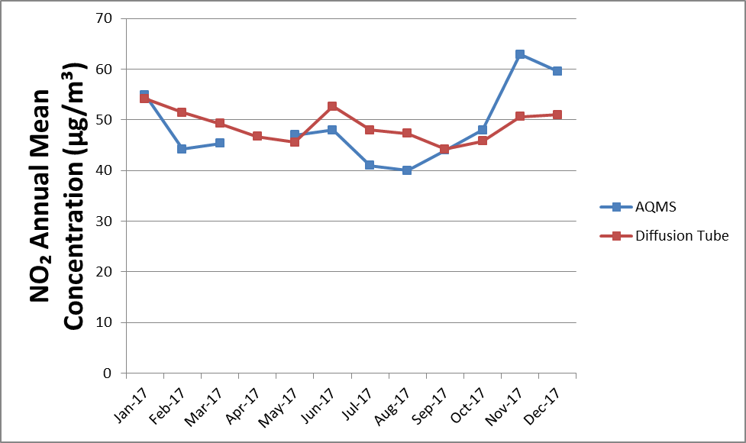

  - Annual Mean NO₂ Concentrations
The mean NO₂ concentration over the whole network during 2017 was 35.5 µg/m³ applying the local bias adjustment factor of 1.00. The mean concentration calculated using the national bias adjustment factor was 34.4 µg/m³. Using either bias adjustment factor, the mean concentration across the whole network is below the annual mean NO₂ objective of 40 µg/m³. The maximum annual mean NO₂ concentration was measured at the LWS017 site at 9 Baring Road (55.5 µg/m³). The second highest annual mean NO₂ concentration was measured at LWS016 at Montpelier Vale (52.4 µg/m³). LWS017 and LWS016 are both roadside sites.
Table 4 Annual Mean NO₂ Concentration (Bias Adjusted), 2017
Site Type | Annual Mean NO₂ Concentration (µg/m³)
Site Type | Raw | Bias Adjusted, using New Cross Co-located Tubes  (Factor = 1.00)* | Bias Adjusted, using National Bias Adjustment Factor  (Factor = 0.97)*
All Sites | 35.6 | 35.5 | 34.4
Roadside | 40.1 | 40.1 | 38.9
Urban Background | 30.2 | 29.9 | 29.0
*Annualised
    - Comparison with Limit Values and Objectives
The air quality objectives and limit values of relevance to NO₂ in the UK are detailed in Table 1. The results in Table 4, obtained after applying the local bias adjustment factor, indicate that the annual mean NO₂ objective of 40 µg/m³ was not generally exceeded within the diffusion tube network during 2017, except at roadside sites. From Appendix B, it can be seen that bias-adjusted annual mean NO₂ concentrations, applying the co-location adjustment factor of 1.00, were greater than 40 µg/m³ at 10 of the 35 diffusion tube locations. Similarly, results based on the national bias adjustment factor show that 9 sites exceeded the NO₂ annual mean objective. These results may be partly due to the fact that concentrations at urban background sites were often considerably below the annual mean objective, whilst roadside sites generally exceeded the annual mean objective.
A report issued by Air Quality Consultants analysed the relationship between annual mean and hourly mean NO₂ concentrations, concluding that locations where the annual mean concentration is greater than 60 µg/m³ may be susceptible to breaches of the hourly mean objective (hourly mean NO₂ concentration of 200 µg/m³ or more not to be exceeded more than 18 occasions per year). After bias adjustment, there are no sites with measured NO₂ concentrations greater than 60 µg/m³ in 2017.
    - Seasonal Variation
The seasonal variation in NO₂ concentrations during 2017 are shown in Table 5 and Figure 2. Due to seasonal variations in the bias adjustment that can occur at diffusion tube sites, the results that have been presented are the raw concentrations with no bias adjustment applied.
The highest mean concentrations occurred in January and February at roadside sites. For urban background sites, the highest mean concentrations were measured during January and November. Mean NO₂ concentrations were lowest in June and July for all site types.
Table 5 Monthly Mean NO₂ Concentrations in Lewisham, 2017 (µg/m³; Unadjusted)
Site Type | Jan | Feb | Mar | Apr | May | Jun | Jul | Aug | Sep | Oct | Nov | Dec
All Sites | 49.8 | 40.4 | 35.1 | 32.4 | 31.7 | 29.9 | 29.9 | 32.6 | 32.4 | 34.8 | 40.2 | 38.2
Roadside | 53.7 | 44.5 | 39.7 | 37.4 | 36.4 | 35.4 | 35.0 | 37.4 | 36.1 | 38.7 | 43.5 | 41.5
Urban Background | 43.4 | 33.7 | 28.4 | 24.6 | 24.0 | 22.0 | 21.9 | 24.9 | 26.0 | 28.8 | 35.2 | 33.6

Table 6 Unadjusted Winter and Summer Period Mean Concentrations in Lewisham, 2017
Site Type | Winter Mean Concentration  (October – March) (µg/m³) | Summer Mean Concentration  (April – September) (µg/m³) | Ratio Winter : Summer
All Sites | 39.7 | 31.5 | 1.26
Roadside | 43.6 | 36.3 | 1.20
Urban Background | 33.9 | 23.9 | 1.42

Table 6 shows that the ratio of winter to summer mean NO₂ concentration was 1.20 for roadside sites, indicating mean concentrations were higher in the winter than the summer period. The urban background sites display a greater winter: summer ratio compared to roadside sites with a value of 1.42 in 2017. For all sites, collectively, the ratio of winter to summer mean NO₂ concentration was 1.26.
Figure 2: Seasonal Trend of NO₂ Concentrations in Lewisham, 2017
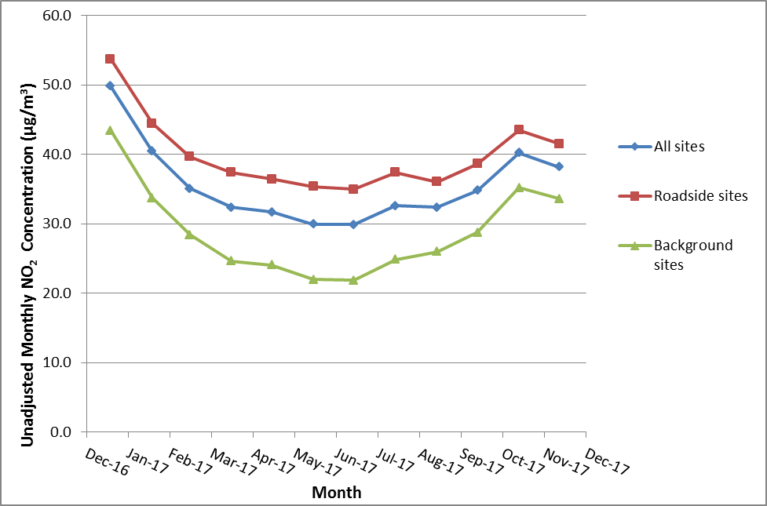
  - Historical Trends
Table 7 summarises the results of the Lewisham Tube Network by site type from 2012 to 2017; results for each site in 2017 are detailed in Appendix B. These results have been bias adjusted and the factors can be found in Appendix C Table 9.
Measurements from the past year showed a slight decrease in annual mean NO₂ concentration across the network between 2016 and 2017 when considering the highest adjustment factor. , The national bias adjustment factor for 2016 was slightly greater than the local bias adjustment factor for 2017, but generally very similar to those in previous years.
Table 7 Annual Mean NO₂ Concentration (bias-adjusted) by Site Type, 2012 – 2017
Site Type | Bias Adjusted Annual Mean NO₂ Concentration (µg/m³)
Site Type | 2012 |  |  | 2013 |  | 2014
Site Type | Bias Adjusted using New Cross Co-located tubes  (Factor = 0.79) |  | Bias Adjusted using National Bias Adjustment factor  (Factor = 1.01) | Bias Adjusted using New Cross Co-located tubes  (Factor = 0.93) | Bias Adjusted using National Bias Adjustment factor  (Factor =1.0) | Bias Adjusted using New Cross Co-located tubes  (Factor = 0.82) | Bias Adjusted using National Bias Adjustment factor  (Factor =0.97)
All Sites | 31.7 |  | 40.6 | 39.1 | 42.0 | 33.1 | 38.8
Roadside | 35.9 |  | 46.0 | 44.0 | 47.7 | 37.6 | 44.2
Urban Background | 25.6 |  | 32.7 | 31.9 | 33.7 | 26.5 | 31.3
Site Type | Bias Adjusted Annual Mean NO₂ Concentration (µg/m³)
Site Type | 2015 |  |  | 2016 |  | 2017
Site Type | Bias Adjusted using New Cross Co-located tubes  (Factor = 1.02) | Bias Adjusted using National Bias Adjustment factor  (Factor = 0.95) |  | Bias Adjusted using New Cross Co-located tubes  (Factor = 0.92) | Bias Adjusted using National Bias Adjustment factor  (Factor = 1.03) | Bias Adjusted using New Cross Co-located tubes  (Factor = 1.00) | Bias Adjusted using National Bias Adjustment factor  (Factor = 0.97)
All Sites | 37.7 | 35.1 |  | 34.5 | 38.7 | 35.5 | 34.4
Roadside | 43.5 | 40.5 |  | 39.4 | 44.1 | 40.1 | 38.9
Urban Background | 29.3 | 27.3 |  | 27.4 | 30.7 | 29.9 | 29.0

The main conclusions of the 2017 Lewisham Diffusion Tube Network study are:
- Conclusions
- The mean NO₂ concentration for the whole network, based on local bias adjustment factor was 35.5 µg/m³.
NO₂ concentrations were greatest at roadside monitoring locations, and lowest at urban background sites, as expected. The highest annual mean NO₂ concentration in 2017 was measured at site LWS017 (9 Baring Road). The mean concentration was 55.5 µg/m³ using the local bias adjustment factor. The second highest annual mean NO₂ concentration occurred at LWS016 at Montpelier Vale with a concentration of 52.4 µg/m³.
- The mean roadside NO₂ concentration across the network was 40.1 µg/m³ based on the local bias adjustment factor and the mean urban background concentration was 29.9 µg/m³.
- Results obtained after applying the local bias adjustment factor show that 10 sites exceeded the annual mean NO₂ objective of 40 µg/m³. Results based on the national adjustment factor show that 9 diffusion tube locations recorded annual mean NO₂ concentrations exceeding the annual mean NO₂ objective.
- None of the locations recorded an annual mean above 60 µg/m³, indicating that it is unlikely that the short term objective was exceeded in 2017.

Appendices
Appendix A: Diffusion Tube Monitoring Locations in Lewisham
Figure 3: LB of Lewisham Diffusion Tube Network (South) in 2017
7
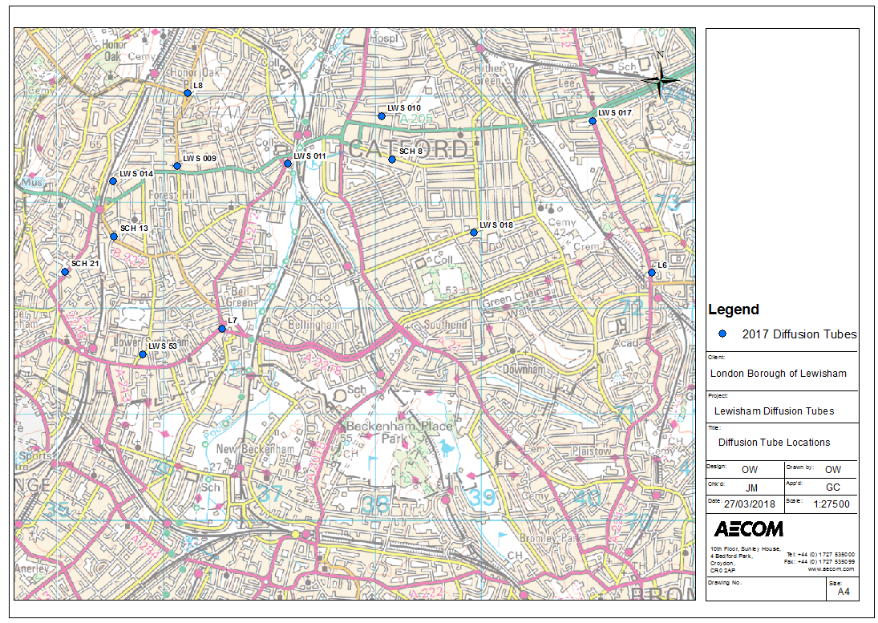
Figure 4: LB of Lewisham Diffusion Tube Network (North) in 2017
6
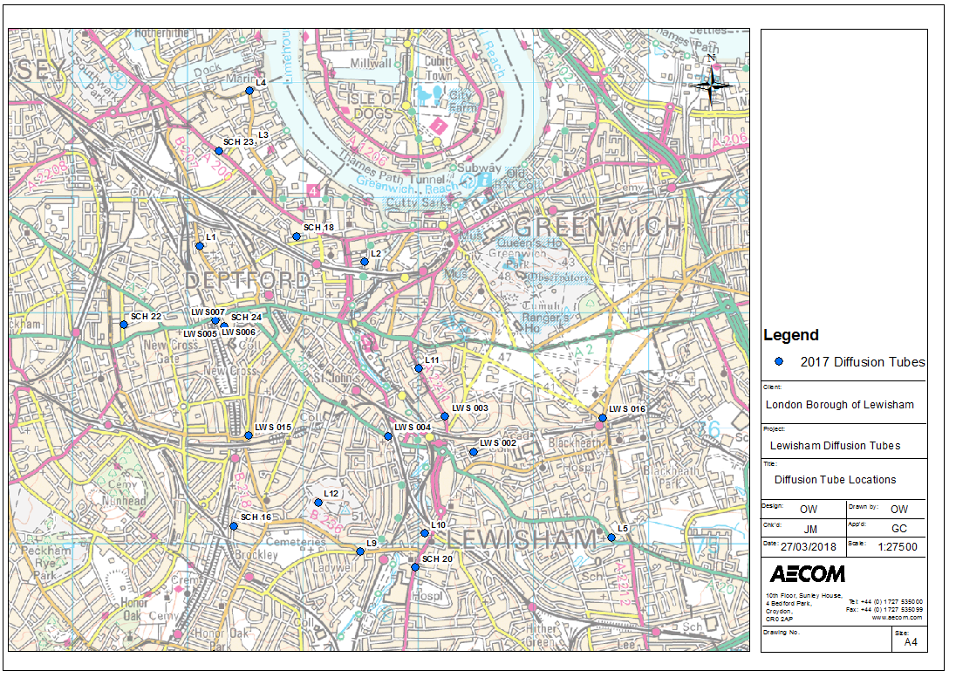
Appendix B: Monitored NO₂ Concentrations
Table 8 Lewisham Diffusion Tube Network 2017 – Raw and Bias Adjusted Results
Old Ref | New Ref | Location | X | Y | Site Type | Annual Mean NO₂ Concentration (µg/m³) |  |  | Data Capture (%)
 |  |  |  |  |  | Raw | Bias-Adjustedª  (Factor = 1.00) | Bias-Adjusted^{b}  (Factor = 0.97) | Data Capture (%)
L1 | L1 | Chubworthy Street / Sanford Street SE14 6HD | 536109 | 177580 | Roadside | 31.6 | 31.6 | 30.7 | 100
L2 | L2 | Bronze Street / Creekside SE8 3DX | 537540 | 177439 | Urban Background | 29.0 | 29.0 | 28.1 | 100
L3 | L3 | Oxestalls Road / Grove Street SE8 3QQ | 536561 | 178471 | Urban Background | 32.7 | 32.7 | 31.7 | 100
L4 | L4 | Plough Way / Grove Street SE16 7FH | 536534 | 178926 | Urban Background | 31.7 | 31.7 | 30.7 | 100
L5 | L5 | 307 Lee High Road SE12 8RU | 539678 | 175050 | Roadside | 30.0 | 30.0 | 29.1 | 100
L6 | L6 | Baring Road / Le May Avenue SE12 0DU | 540615 | 172337 | Urban Background | 32.2 | 32.2 | 31.2 | 100
L7 | L7 | 65 Bell Green SE26 5SJ | 536556 | 171810 | Roadside | 43.3 | 43.3 | 42.0 | 92
L8 | L8 | 107 Stondon Park SE23 1LD | 536229 | 174032 | Roadside | 38.6 | 38.6 | 37.5 | 100
L9 | L9 | Adelaide Avenue / Ladywell Road SE13 7HS | 537500 | 174925 | Roadside | 35.1 | 35.1 | 34.1 | 92
L10 | L10 | Bexley Court, Whitburn Road SE13 7UQ | 538062 | 175085 | Roadside | 37.3 | 37.3 | 36.2 | 92
L11 | L11 | Lewisham Road / Sparta Street SE13 7QP | 537965 | 176617 | Roadside | 34.8 | 34.8 | 33.7 | 100
L12 | L12 | Montague Avenue SE4 1YP | 537132 | 175353 | Urban Background | 26.4 | 26.4 | 25.6 | 100
LWS 53 | L13 | 50 Mayow Road SE26 4JA | 535804 | 171567 | Urban Background | 26.6 | 26.6 | 25.8 | 100
LWS 002 | L14 | 24 Boyne Road SE13 5AL | 538482 | 175792 | Urban Background | 29.2 | 29.2 | 28.3 | 100
LWS 003 | L15 | 155 Lewisham Road SE13 7PZ | 538237 | 176101 | Roadside | 36.3 | 36.3 | 35.2 | 100
LWS 004 | L16 | 122 Loampit Vale SE13 7SN | 537740 | 175930 | Roadside | 44.1 | 44.1 | 42.8 | 100
LWS 005  LWS 006  LWS 007 | L17  L18  L19 | 272 New Cross Road SE14 5DS | 536246 | 176934 | Roadside | 48.9 | 48.9 | 47.4 | 100
LWS 008 | L20 | New Cross Road / Hatcham Park Road SE14 5DG | 535746 | 176969 | Roadside | 38.6 | 38.6 | 37.5 | 100
LWS 009 | L21 | 10-18 Brockley Rise SE23 1JN | 536133 | 173341 | Roadside | 49.7 | 49.7 | 48.2 | 100
LWS 010 | L22 | 68 Ringstead Road SE6 2BS | 538060 | 173816 | Urban Background | 31.9 | 31.9 | 30.9 | 92
LWS 011 | L23 | 33b Catford Hill SE6 4NU | 538007 | 176517 | Roadside | 44.5 | 44.5 | 43.1 | 100
LWS 014 | L25 | 8 Stanstead Road SE23 1BW | 535530 | 173198 | Urban Background | 23.1 | 23.1 | 22.4 | 100
LWS 015 | L26 | 205 Shardeloes Road SE4 1BE | 536527 | 175935 | Roadside | 43.5 | 43.5 | 42.2 | 92
LWS 016 | L27 | Montpelier Vale, SE3 0TA | 539604 | 176090 | Roadside | 52.4 | 52.4 | 50.9 | 100
LWS 017 | L28 | 9 Baring Road SE12 0JP (Baring Road / Westhorne Avenue) | 540051 | 173769 | Roadside | 55.5 | 55.5 | 53.8 | 100
LWS 018 | L24 | Hazelbank Road / Birkhall Road SE6 1TG | 538930 | 172713 | Urban Background | 33.3 | 33.3 | 32.3 | 100
SCH 8 | L29 | 147 Sangley Road SE6 2DY | 538165 | 173406 | Roadside | 29.0 | 29.0 | 28.2 | 92
SCH 13 | L30 | Perry Vale / Dacres Road SE23 2NE | 535535 | 172679 | Roadside | 28.1 | 28.1 | 27.3 | 83
SCH 16 | L31 | 85 Howson Road / Whitbread Road SE4 2AU | 536399 | 175150 | Urban Background | 24.4 | 24.4 | 23.6 | 92
SCH 18 | L32 | Clyde Street / Larch Close SE8 5TW | 536944 | 177665 | Urban Background | 28.4 | 28.4 | 27.5 | 92
SCH 20 | L33 | Lewisham High Street / Romborough Way | 537979 | 174792 | Roadside | 40.7 | 40.7 | 39.5 | 75
SCH 21 | L34 | Dartmouth Road / Round Hill SE26 4RD | 535071 | 172346 | Urban Background | 26.4 | 26.4 | 25.6 | 92
SCH 22 | L35 | Kender Primary School | 535447 | 176897 | Roadside | 31.3 | 31.3 | 30.4 | 92
SCH 23 | L36 | Deptford Park Primary School | 536275 | 178405 | Roadside | 43.1 | 43.1 | 41.8 | 100
SCH 24 | L37 | St James Hatchem Primary School | 536317 | 176883 | Urban Background | 33.2 | 29.2* | 28.3* | 25
Note: ª Bias adjustment factor is calculated based on results from Lewisham,-New Cross monitoring station. ^{b} National Bias adjustment factor. * Annualised according to Defra Guidance LAQM.TG(16)
Appendix C: Diffusion Tube Bias Adjustment
A local bias adjustment factor was calculated in order to apply a locally-derived bias correction to the raw diffusion tube results for 2017. Triplicate tubes are co-located alongside the continuous NO₂ monitoring station at New Cross Road (LW2). The national bias adjustment factor for Lewisham was also obtained from the Defra website, which is the average of the 22 bias adjustment factors for local authorities using Gradko 50% TEA/acetone analysis method.
The continuous monitoring site listed above is part of the London Air Quality Network (LAQN reference is given in brackets). NO₂ concentration data from the continuous monitoring sites between 05/01/2017 and 08/01/2018 to cover the period of diffusion tube monitoring was collated. Period mean NO₂ concentrations were calculated for each diffusion tube exposure period during 2017. Data capture statistics for the same periods were also determined.
The continuous monitoring data and raw triplicate tube concentrations were inputted into the Bias Adjustment Calculator tool to calculate bias adjustment factors.
The bias adjustment calculations for the monitoring site are shown in Figure 4. Table 9 provides a summary of the bias factor calculated for the site, and the comparison with national bias adjustment factors for the past years are also shown.
Table 9 Summary of Local and National Bias Adjustment Factors for Lewisham NO₂ Diffusion Tube Surveys, 2009 to 2017
Year | Mean Local Factor | National Factorª
2009 | 0.84 | 0.97
2010 | 0.69 | 1.03
2011 | 0.59 | 0.95
2012 | 0.79 | 1.01
2013 | 0.93 | 1.00
2014 | 0.82 | 0.97
2015 | 1.02 | 0.95
2016 | 0.92 | 1.03
2017 | 1.00 | 0.97
Notes: ª National factor obtained from Bias Adjustment Factor spreadsheet³ version 03/18 based on Gradko as the analysing laboratory using the 50% TEA in acetone method;

Figure 4: Local Bias Adjustment Factor Calculation, Lewisham – New Cross (LW2)

Figure 5: National Bias Adjustment Factor Calculation

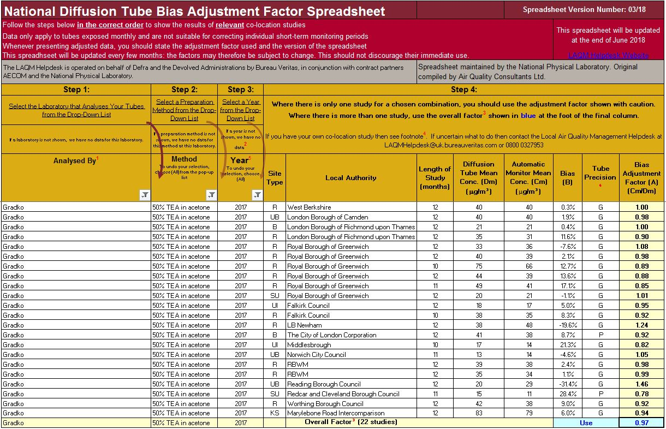

Defra, The Air Quality Strategy for England, Scotland, Wales and Northern Ireland, 2007.
Defra, Local Air Quality Management, Diffusion Tubes, Nitrogen Dioxide Diffusion Tube Monitoring, Calendar of Suggested Exposure Periods. Available at http://laqm.defra.gov.uk/diffusion-tubes/data-entry.html
Summary of Laboratory Performance in AIR NO₂ Proficiency Testing Scheme. Available at: https://laqm.defra.gov.uk/assets/AIR-PT-Rounds-13-to-24-Apr-2016-Feb-2018.pdf
Defra, Local Air Quality Management Technical Guidance LAQM.TG(16), April 2016.
Defra, National Diffusion Tube Bias Adjustment Factor Spreadsheet (Version 03/18). Available at http://laqm.defra.gov.uk/bias-adjustment-factors/national-bias.html
AEA Diffusion Tube Precision Accuracy Bias Spreadsheet. Downloaded from http://laqm.defra.gov.uk/bias-adjustment-factors/local-bias.html March 2018.
London Air Quality Network Website. Available at http://www.londonair.org.uk.
Cape, J.N., Review of the Use of Passive Diffusion Tubes for Measuring Concentrations of Nitrogen Dioxide in Air, 2005. Available at http://uk-air.defra.gov.uk/reports/cat05/0810141025_NO2_review.pdf
Air Quality Consultants (2007). Deriving NO₂ from NO_{X} for Air Quality Assessments of Roads.

